**GC PRACTICAL: CASE STUDY**

**COMPARATIVE STUDY OF RoHS AND WEEE DIRECTIVES.**

**OVERVIEW**

1. Introduction
2. What is RoHS
3. Brief about RoHS in various countries
4. Comparative study of Indian RoHS and EU RoHS
5. Indian RoHS
6. Rules and regulations
7. The need
8. Testing facilities
9. Testing procedure
10. EU RoHS
11. Rules and regulations
12. The need
13. Testing procedure
14. WEEE directives
15. Conclusion
16. Bibliography

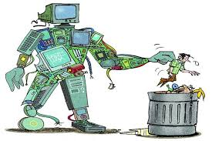

*Name: Aaditya Pal*

*Control id: 2021080314*

*Roll no: 3843A031*

*Class: FYBsc-IT*

**INTRODUCTION**

We live in a very fast growing world. Over the years, we have become heavily dependent on electronic devices like computers, mobile phones, etc. Hence, there is continuous innovation, research in this sectors. Computers have become a very essential part of our lives. From industries, companies to every common man electronic devices are used. With the occurrence of Covid our lives have changed completely. Our dependency on these devices has increased significantly. Everyone’s workflow changed significantly .From schools being conducted through online to business, governmental meetings were being conducted through online means.

Due to all these factors in today's digitalizing world, E-waste has become a significant problem. Understanding E-waste and its management is very important because if neglected it can cause some serious damages to the environment in which we live in. This is where RoHS and WEEE directives come into play.

Realizing this several countries have introduced some rules and regulations to keep this under control and have been continuously monitoring, analyzing this issue. The European Union first enacted Restriction on Hazardous substances (RoHS) to control hazardous substances in electrical and electronic products. Seeing this several other regions took inspiration and have done the same. India is a very good example. We take a closer look into specific countries and its ROHS directives such as the EU and India and compare them. The RoHS directives of all countries are inspired by the EU’s directives. But there are quite evident changes made to tailor to the problems and issues regarding that specific country.

**What is RoHS?**

The Restriction of Hazardous Substances Directive abbreviated as RoHS is a set of rules and regulations of the European Union on the restriction of the use of certain hazardous substances in electrical and electronic equipment. The main objective of this legislation is to eliminate or reduce the use of various harmful substances such as cadmium, hexavalent chromium, and lead in a various range of electrical products. It mainly restricts the use of six hazardous materials used in various types of electronic and electrical equipment. They are as follows:-

1. Lead
2. Cadmium
3. Mercury
4. Hexavalent Chromium
5. Polybrominated Biphenyls(PBB)
6. Polybrominated Diphenyl Ether (PDB)

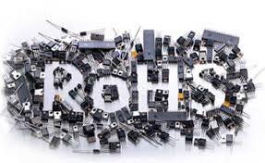

The six substances are very critical for design, development and functionality of various electronic products. Let us see where these substances most frequently found:-

1. **Lead**

Lead is found in the following:

* Lead acid batteries contain approximately 58% of lead.
* Tin-lead alloys are most widely used as solder in the electronics industry. The solder is used in personal computers, laptop, printer, copier, mobile phone, video games, television sets etc.
* Leaded glass and ceramics use lead oxide and Crystal glass contains 24-36% of lead oxide.
* Lead compounds are used in PVC stabilizers, which is used in electrical cable insulation, cell phone housing, etc.

1. **Cadmium**

Cadmium or cadmium oxides are used in following cases:

* Cadmium oxide is used in nickel-cadmium batteries, where nearly 72% of cadmium is present. Nickel- cadmium batteries are used in cell phones, toys, clocks, older laptops etc.
* Cadmium oxide or metal is used in PVC to retard degradation on exposure to heat and UV light.
* Cadmium is used for metal plating for protection of iron against corrosion.
* Cadmium is a common metal of various alloys used due to their melting temperatures. Tin-lead-bismuth- cadmium alloy joins heat sensitive metal parts, silver- cadmium-copper-zinc-nickel joins tungsten carbide to steel tools.
* Cadmium is also present in copper-cadmium alloys, solders, solar cells etc. Cadmium plating or solder is very common in semiconductors in computers, toys, mobile phones

1. **Mercury**

Mercury is used in following cases:

* Mercury bottom cells are used in watches and batteries.
* Mercury is also used in measuring and control instruments, lighting, fluorescent tubes, older switches in some electrical equipment.
* Gold and silver recovery in printed circuit board recycling plants.

1. **Chromium VI**

Cr (VI) or chromium VI is used in following cases:

* Chromate coatings are used on various metals to protect metal parts from corrosion.
* Chromium in glass is used to achieve emerald green colored glass
* Chromium VI pigments are important for coating on electrical contacts and fasteners in aluminum, in all electrical equipment. The chromium coating is also used in cooling systems of refrigerators.
* Chromium coating on copper foil is needed in lithium ion batteries in laptops, mobile phones and video games etc. This coated copper foil is also used on printed circuit boards of all electronic equipment.

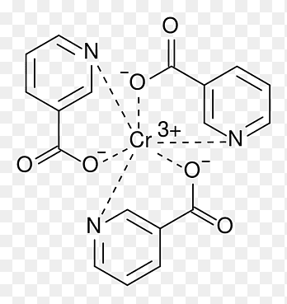

*Figure: Hexavalent Chromium*

1. **Polybrominated biphenyls (PBB) and polybromina- teddiphenyl ethers (PBDEs)**

. They are used in the following products:

* PBB and PBDE are used in different plastics and textiles, as a flame retardant
* Deca-BDE housings are used in TV sets, mobile phones, wire and cable, connectors in electrical and electronic equipment
* Octa-BDE housings are in TV sets, PC monitors, mobile phones, in connectors, switches, circuit breakers in most electrical equipment, some types of circuit boards, plastic parts in copiers and lamp socket.

**Brief about RoHS in various countries**

     The European Union had first initiated the campaign against the Restriction on Hazardous Substances (RoHS) by enacting its Directive.

This directive controls the manufacturing of electronic and electrical equipment using hazardous substances like lead, cadmium, mercury, hexavalent chromium, polybrominated biphenyls, and polybrominated diphenyl ethers exceeding a certain level. The ROHS directive is also known as "Lead-Free'' legislation. This directive had excluded certain items such as compact fluorescent lamp (CFLs), cathode ray tube (CRT) etc.

RoHS compliant electronics products had started entering the EU market. The EU countries took a proactive role in banning a number of products containing RoHS using “precautionary and substitution” principles. The RoHS Directive established a regulatory process of placing bans on lead and cadmium, which are essential to the functionality, safety, and reliability of electrical and electronic products. Review of the effects of the directive is being taken time to time at EU. The EU has agreed that bans must be made based on risk assessments. The EU is working to decide whether there should be additional exemptions listed in the RoHS directive. European Commission reviewed the terms of the Directive based on the experiences during the first few years of operations of the RoHS.

    The RoHS Directive of the EU was a first that influenced other countries around the world to do the same. Some countries are the USA, Norway, China, South Korea and Japan among many others.

**Comparative study of the Indian RoHS and the EU RoHS**

We are going to take a closer look at the RoHS directives implemented in the Indian subcontinent and the European Union. Comparing the directives will give us a much closer look at the seriousness of the problem and the actions taken in regard to those issues. As the European Union was the first to recognize and act on the issue of E-waste it makes it a no-brainer to compare it to the rest. India has also taken a few significant steps in the right direction but comparing it that of European Union will gives an idea on what and how things need to be done. It will help in getting a much closer look at the India’s development on the E-waste issue and how it resolves it. As a citizen, it makes one more aware about the problems faced and makes him/her more self-conscious while using and disposing E-waste correctly. Hence, the two are compared. The comparison will take place on the basis of a few points:

* The Impact after the implementation of the rules
* Testing facilities
* How testing is carried out

1. **INDIAN RoHS**

**THE RULES AND REGULATIONS**

The Ministry of Environment and Forest (MoEF), Government of India is the primary agency to address the issue related to RoHS and Electronic waste. MoEF has notified the electronic wastes Rules, to address the safe and environmentally friendly handling, transporting, storing, and recycling of electronic waste and also to reduce the use of hazardous substances during manufacturing of electrical and electronic equipment. These are the first ever-exclusive rules on electronic waste in India.

The rules have covered the reduction in the use of hazardous substances (RoHS) in the manufacture of the electrical and electronic equipment. These rules RoHS have come into force from 2014. The electronic wastes rules address reduction in the use of hazardous substances in the manufacture of electrical and electronic products in the following ways:-

1. Every producer of electrical and electronic equipment shall ensure that new electrical and electronic equipment do not contain lead, mercury, cadmium, hexavalent chromium, polybrominated biphenyls or ethers. Provided that a maximum concentration value of 0.1% by weight in homogeneous materials for lead, mercury, Hexavalent chromium, by weight in homogeneous materials for cadmium shall be permitted.
2. The components of electrical and electronic equipment manufactured or placed on the market six years before the date of commencement of these rules are also exempted.
3. In the event of a reduction in the hazardous materials used in the electrical and electronic equipment, the detailed information on the constituents of the equipment, need to be provided in the product information booklet.
4. Imports or placement in the market for new electrical and electronic equipment, which are compliant to rule, shall only be permitted.
5. Manufacture and supply of electrical and electronic equipment used for defense and other similar strategic applications shall be excluded from the rule.
6. Such reduction in use of hazardous substances in manufacture or imported electrical and electrical equipment shall be achieved within a period of two years from the date of commencement of these rules.

**THE NEED**

A survey was carried out in the year 2005 by the Central Pollution Control Board (CPCB) and the e-waste generated was calculated to an approximately 146180 tons. And it was estimated that there would be a significant increment in this number in the years to come. For example it was estimated that the e-waste generated in 2012 would exceed the previous number by 8,00,000 tons by 2012. Hence, E waste and its management became a huge concern and various rules and regulations were implemented.

India ranks 177 amongst 180 countries and is amongst the bottom five countries on the

Environmental Performance Index 2018, as per a report released at the World Economic Forum in 2018. This was linked to poor performance in the environment health policy and deaths due to air pollution categories. Also, India is ranked fifth in the world amongst top e-waste producing countries after the USA, China, Japan, and Germany and recycles less than 2 per cent of the total e-waste it produces annually formally .Since 2018, India generates more than two million tons of e-waste annually, and also imports huge amounts of e-waste from other countries around the world. Dumping in open dumpsites is a common sight which gives rise to issues such as groundwater contamination, poor health, and more. The Associated Chambers of Commerce and Industry of India (ASSOCHAM) and KPMG study, Electronic Waste Management in India identified that computer equipment account for almost 70 per cent of e-waste, followed by telecommunication equipment phones (12 per cent), electrical equipment (8 per cent), and medical equipment (7 per cent) with remaining from households .E-waste collection, transportation, processing, and recycling is dominated by the informal sector. The sector is well networked and unregulated. Often, all the materials and value that could be potentially recovered is not recovered. In addition, there are serious issues regarding leakages of toxins into the environment and workers’ safety and health. *Seelampur* in *Delhi* is the largest e-waste dismantling center of India. Adults as well as children spend 8–10 hours daily extracting reusable components and precious metals like copper, gold and various functional parts from the devices. E-waste recyclers use processes such as open incineration and acid-leeching. This situation could be improved by creating awareness and improving the infrastructure of recycling units along with the prevalent policies. The majority of the e-waste collected in India is managed by an unorganized sector. Also, informal channels of recycling/reuse of electronics such as repair shops, used product dealers, e-commerce portal vendors collect a significant proportion of the discarded electronics for reuse and cannibalization of parts and components.

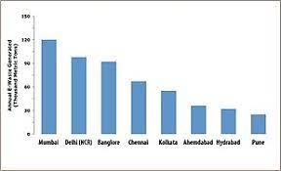

The above graph shows that in India, the amount of e-waste generated differs by state and various cities around the country. Mumbai generates the maximum amount of E-waste of any city in the country followed by various other major cities. The three states that produce the most e-waste are as follows: [Maharashtra](https://en.wikipedia.org/wiki/Maharashtra), [Tamil Nadu](https://en.wikipedia.org/wiki/Tamil_Nadu) and [Andhra Pradesh](https://en.wikipedia.org/wiki/Andhra_Pradesh). Other states that produce significant e-waste are [Uttar Pradesh](https://en.wikipedia.org/wiki/Uttar_Pradesh), [West Bengal](https://en.wikipedia.org/wiki/West_Bengal), [Delhi](https://en.wikipedia.org/wiki/Delhi), [Karnataka](https://en.wikipedia.org/wiki/Karnataka), [Gujarat](https://en.wikipedia.org/wiki/Gujarat), [Madhya Pradesh](https://en.wikipedia.org/wiki/Madhya_Pradesh) and [Punjab](https://en.wikipedia.org/wiki/Punjab).

Additionally, e-waste is disproportionately generated in urban areas—65 Indian cities generate more than 60% of India's total e-waste. [Mumbai](https://en.wikipedia.org/wiki/Mumbai) is the top e-waste producer followed by [Delhi](https://en.wikipedia.org/wiki/Delhi), [Bengaluru](https://en.wikipedia.org/wiki/Bangalore), [Chennai](https://en.wikipedia.org/wiki/Chennai), and [Kolkata](https://en.wikipedia.org/wiki/Kolkata).

The above graph clearly shows that in the year 2017-18 over 7,00,000 tons of E- waste while on 69,000 tons was recycled. Similarly, in the years 2018-19 over 7,500,000tons of E waste was generated while only 2,00,000 was recycled and in the year 2019-20 this number rose to new levels as over 10,00,000 tons of E waste was generated while only over 2,50,000 tons was recycled. Hence, a lot of waste if left untreated which is a big concern and responding to this the WEEE were enacted and they were made more rigid.

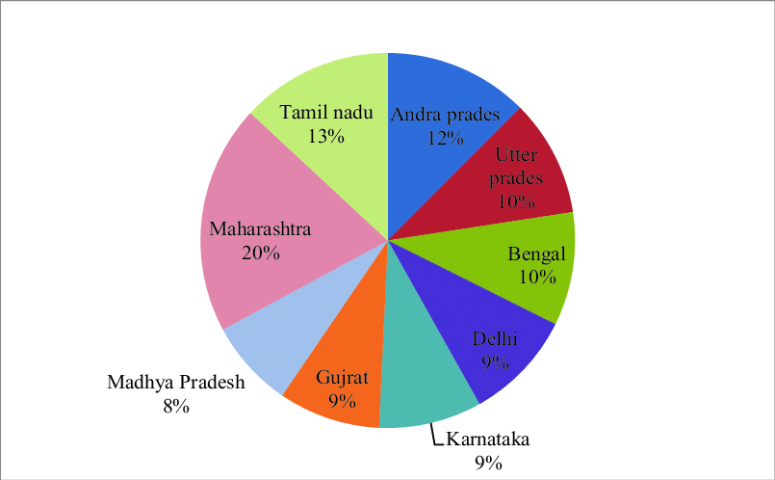

**THE IMPLEMENTATION**

For the implementation of RoHS of e-waste (Management & Handling) Rules, a framework was followed .It was framed to have a structure in place to carry out the implementation successfully. The following points were mentioned:-

* Central Pollution Control Board (CPCB)  would implement the RoHS provision  which would be based on a self-regulation model that included the following points:
* Creating a registry of producers and maintaining it.
* A self-declaration on RoHS compliance mechanism to be developed.
* c. To formulate a dynamic database on various EEEs which would be placed in the market.
* For granting the EPR authorization, The State Pollution Control Boards (SPCBs)/ Pollution Control Committees (PCCs) were required to have information on RoHS. More on EPR:
* In the E-waste management section, Extended Producers Responsibility (EPR) has been stated. According to it, the producers are required to collect e-waste generated from the end of life of their products by setting up collections centers or take back systems either individually or collectively
* .E-waste recycling can be undertaken only in facilities authorized and registered with State Pollution Control Boards/Pollution Control Committee (PCCs). Under these rules EPR authorizations have been granted to 128 Producers which are spread in 11 states. 134 collection centers are set-up in 19 States.

**TESTING FACILITIES**

1. **Private sector**

To address the ever growing issue of e waste something had to be done. Indian electronic and hardware industries had been facing a problem in exporting electronic products EU countries since the implementation RoHS Directive of the EU. India has limited testing facilities or laboratories dedicated to the RoHS test. As the rules were implemented the demand for such facilities was increasing that complies with the RoHS rules. To address this demand of the industry several private laboratories had initiated RoHS testing. Table 2 provides few such laboratories and their facilities:

1. Bangalore Test House (BTH), Karnataka

2. Sargam Labs. Pvt. Ltd Chennai

3. TUV-Rehinland India Pvt. Ltd.,

4. Hiram Institute for Industrial Research

5. Doctors Analytical Laboratories,

6. Shiva Analyticals (India) Ltd

7. Geo-Chem Laboratories Pvt Ltd

8. Arbro Pharmaceuticals Ltd.

1. **Government Initiatives**

The government had to take some initiatives to create a well-equipped government facility in India from the manufacturing industries for bringing transparency and neutrality of the test report. For this purpose, RoHS testing centers require an adequate research base, knowledge and technical skills in order to successfully attain the results in the reduction of harmful effects of e waste. The Department of Electronics and Information Technology has therefore created a facility of the RoHS at Centre for Materials for Electronics Technology (C-MET), Hyderabad, which is one of the premier R&D institutions in the country under this Department. C-MET is the leading organization for the development of electronics materials, high purity metals, and electro- ceramics. The laboratory has robust R&D infrastructure facilities to carry out high-end research and development projects. This facility is the only government owned laboratory, which has obtained the accreditation from the National Accreditation Board for Testing and Calibration Laboratories. The laboratory is fully equipped with world recognized analytical equipment’s for RoHS testing. The international standard procedures are followed for the testing. Installed equipment’s are inductively coupled plasma-mass spectrometer, ion chromatography ,gas chromatograph – Mass spectrometer, energy dispersive x-ray fluorescence spectrometer ,atomic absorption spectroscopy ,etc.

**HOW ROHS TESTING TAKES PLACE IN INDIA**

1. **Energy Dispersive X-ray Fluorescence spectrometer (EDXRF)**

The Energy Dispersive X-ray Fluorescence Spectrometer has been installed at CMET, Hyderabad for testing hazardous elements. The EDXRF uses non-destructive technique and multi-elemental analysis with excellent sensitivity. This prerequisite instrument decides the pass or fails RoHS elements like Pb, Cd, Hg, all Cr ions and Br in part per million (ppm) levels. The equipment provides the accurate and fast analysis with mapping facility. The existence of hazardous substances can be confirmed in liquid, solid or film by screening of the samples at EDXRF.

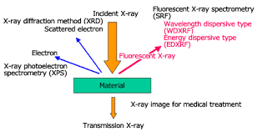

1. **Atomic Absorption Spectrometer**

C-MET, Hyderabad has installed the Atomic Absorption Spectrometer for elemental analysis at ppm level with reasonable accuracy and precision. The principle of AAS is the absorption of light by a free atom in the gaseous state to determine the concentration of a particular element qualitatively and quantitatively. AAS requires standards with known analytic content to establish the relation between the measured absorbent and the analytic concentration using Beer-Lambert Law. The radiation flux with and without a sample in the atomizer is measured to calculate the concentration or mass. The detailed analysis of three elements of RoHS i.e. Pb, Cd & Cr can be made by dissolving the given samples (0.2g) in certain acids by using Microwave Digestion System.

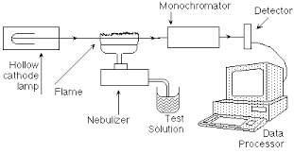

*Figure: Atomic Absorption Spectrometer*

1. **Inductively Coupled Plasma- Mass Spectrometer (ICP-MS)**

Inductively Coupled Plasma- Mass Spectrometer has been installed at C-MET, Hyderabad. ICP works on the principle of atomic emission spectrometry. The instrument executes multi- elemental analysis with excellent sensitivity and high sample throughput. ICP- MS employs plasma as the ionization source and a mass spectrometer analyzer to detect the ions produced. It can simultaneously measure most elements in the periodic table and determine the concentration down to the sub monogram-per-liter (nag/l) or part-per trillion (ppt) level. It can perform qualitative, semi-quantitative, and quantitative analysis, since it employs a mass analyzer.

1. **Ion Chromatography (IC)**

The Ion Chromatography has been installed at C-MET, Hyderabad to primarily analyse hexavalent Chromium at lower levels. Ion Chromatography is the only technique that C-MET can provide quantitative analysis of anions/citations at the ppb level. IC determines ions in liquids and ionic contamination on the surfaces of wafers, chips, and packages. Aqueous solutions, required for filtration, dilution, and/or cleaned to remove interferences, are used for analysis. Plastic samples are extracted with water/organic solutions to remove ions from the sample surface. IC analyzes Hexavalent chromium in any plastic sample.

1. **UV-Vis Spectrophotometer**

C-MET, Hyderabad has installed UV-Visible Spectrophotometer to evaluate hexavalent Chromium in RoHS samples. The Cr6+ is extracted by using UV-VIS with hot water extraction technique. A beam of light from a visible and/or UV light source (collared red) is separated into its component wavelengths by a prism or diffraction grating. Each monochromatic beam in turn is split into two equal intensity beams by a half-mirrored device. One beam, the sample beam, passes through a small transparent container (curette) containing a solution of the compound being studied in a transparent solvent. The other beam, the reference, passes through an identical curette containing only the solvent.

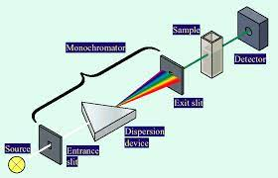

1. **Gas Chromatography – Mass Spectrometer(GC- MS):**

C-MET, Hyderabad has procured Gas Chromatography – Mass Spectrometer to determine the brominated flame retardants. The difference in the chemical properties between different molecules in a mixture will separate the molecules as the sample travels the length of the column. Both PPB and PBDE is analyzed in the given plastic samples by extracting these two components by using a Soxhlet extractor and pre concentrator. The mass spectrometer will quantify the concentrations of PBB and PBDE in plastics.

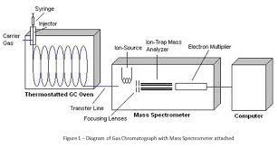

These area various techniques used in testing facilities in India. These are also followed by various testing procedures and complete the testing facility. Now we will take a look at the European Union

1. **EUROPEAN UNION RoHS**

**THE RULES AND REGULATIONS**

The Restriction of Hazardous Substances Directive on the restriction of the use of certain hazardous substances in electrical and electronic equipment, was adopted in February 2003 by the [European Union](https://en.wikipedia.org/wiki/European_Union) .

The RoHS 1 [directive](https://en.wikipedia.org/wiki/European_Union_directive) took effect on 1 July 2006, and is required to be enforced and became a law. This directive restricts the use of ten hazardous materials in the manufacture of various types of electronic and electrical equipment. In addition to the exceptions, there are [exclusions](https://en.wikipedia.org/wiki/Restriction_of_Hazardous_Substances_Directive#Scope_exclusions) for products such as solar panels. It is closely linked with the [Waste Electrical and Electronic Equipment Directive](https://en.wikipedia.org/wiki/Waste_Electrical_and_Electronic_Equipment_Directive) (WEEE) which sets collection, recycling and recovery targets for electrical goods and is part of a legislative initiative to solve the problem of huge amounts of toxic [electronic waste](https://en.wikipedia.org/wiki/Electronic_waste).

* When an EEE is available on the market, distributors act with due care in relation to the requirements applicable in particular by verifying that the EEE bears the CE marking, which is accompanied by the required documents in a language which can be easily understood by consumers and other end-users be made available on the market, and that where a distributor considers or has reason to believe that an EEE is not in conformity, that distributor does not make the EEE available on the market until it has been brought into conformity, and that that distributor informs the manufacturer or the importer as well as the market surveillance authorities to that effect.
* Manufacturers keep the technical documentation and the EU declaration of conformity for 10 years after the EEE has been placed on the market.
* Manufacturers are supposed to ensure that procedures are in place for series production. Changes in product design or characteristics and changes in the harmonized standards or in technical specifications by reference to which conformity of EEE is declared should be taken into account.
* Manufacturers keep a register of non-conforming EEE and product recalls, and keep distributors informed thereof.
* Manufacturers ensure that their EEE bears a type, batch or serial number or other element allowing its identification, or, where the size or nature of the EEE does not allow it, that the required information is provided on the packaging or in a document accompanying the EEE
* Manufacturers indicate their name, registered trade name or registered trade mark and the address at which they can be contacted on the EEE or, where that is not possible, on its packaging or in a document accompanying the EEE. The address must indicate a single point at which the manufacturer can be contacted. Where other applicable Union legislation contains provisions for the affixing of the manufacturer’s name and address which are at least as stringent, those provisions shall apply.
* Manufacturers who consider or have reason to believe that EEE which they have placed on the market is not in conformity with this Directive immediately take the necessary corrective measures to bring that EEE into conformity, to withdraw it or recall it, if appropriate, and immediately inform the competent national authorities of the Member States in which they made the EEE available to that effect, giving details, in particular, of the non-compliance and of any corrective measures taken.

While these are just some of the rules and regulations imposed, there a plenty more where they talk about the obligations on various factors and bodies that contribute to the E waste issue and the guidelines they need to follow. There are obligations on importers of EEE, obligations on manufactures, on authorized representatives on various products that should bear information of the product, etc. There are various penalties imposed if this is not followed. There have been various amendments throughout the years and there have been changes made according to the situation as new products continue to flood the market.

**THE NEED**

In Europe, the total e-waste generation in 2016 was 12.3 Million tons, corresponding to 16.6 kg on average per resident of the member countries. Germany generated 1.9 Million tons in 2016, which is the highest quantity in Europe, Great Britain and Russia generated 1.6 and 1.4 Million tons. Norway generates the highest quantity of e-waste per citizen in Europe, followed by Great Britain and Denmark. Switzerland, Norway, and Sweden show the most advanced e-waste management practices across the globe. However, other countries are still catching up with Northern Europe, whose collection rate is 49%, the highest in the world.

In the European Union, the e-waste management is regulated uniformly by the WEEE Directive. The directive is meant to regulate the collection, recycling, and recovery of e-waste. It includes the provision of national e-waste collection points and processing systems, which enable the proper disposal and treatment of e-waste. This results in a higher quantity of processed e-waste that must be accounted for and reported to the national enforcement authority. The WEEE Directive prescribes that member countries shall encourage the design and production of electrical and electronic equipment, which accounts for and facilitates dismantling and recovery, in particular the reuse and recycling of e-waste, its components, and materials. Member countries shall adopt appropriate measures in order to minimize the disposal of e-waste as unsorted municipal waste, and achieve a high level of separate collection of e-waste. The Directive requires Member States to create systems that allow final stakeholders and distributors to return e-waste free of charge. To guarantee environmentally sound treatment of the separately collected e-waste, the E-waste Directive lays down treatment requirements for specific materials and components of e-waste, and for the treatment and storage sites. This legal framework uses the principle of Extended Producer Responsibility, which requires producers to organize and/or finance the collection, treatment, and recycling of their products at end-of-life. Each Member State of the EU, Norway, Switzerland, and Iceland have implemented national legislation in accordance with the intrinsic conditions of the countries. Since 2016, EU member states have needed to collect 45% of the amount placed on the market, with 65% by 2019, or 85% of the e-waste generated. The official reported numbers by Eurostat have essentially not seen an increase since 2009 and remain about 37% of e-waste generated. A key issue, researched in-detail in the EU. This data shows that the best performing countries in Europe, in terms of collection of e-waste, are Switzerland, which collects 74% of the waste generated, Norway (74%), followed by Sweden (69%), Finland and Ireland (each 55%). Ireland and Denmark collect 50% of the waste generated. Therefore, the highest mentioned collection rates indicate that these countries probably collect all or most of the e-waste, and outperform other countries in the world where collection rates are much lower.

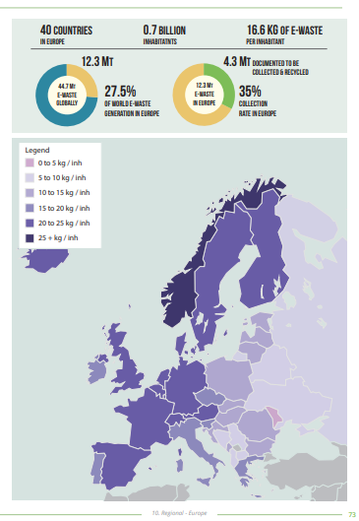

**HOW TESTING IS CARRIED OUT**

Restriction of Hazardous Substances (RoHS) compliance testing is standard procedure for most companies dealing in the production or distribution of electrical and electronic component equipment. The initial method used for RoHS compliance testing is by X-Ray Fluorescence Spectroscopy (XRF). XRF analyzers come in stand-alone, bench-top and handheld formats. Portable, on-site XRF testing using a handheld XRF analyzer is usually performed first and focuses on the parts of a product with the highest risk of containing restricted substances. Other RoHS testing methods used include Fourier Transform Infra-red Spectroscopy (FTIR) testing and sometimes Scanning Electron Microscope (SEM) testing. With the latest amendment of RoHS, RoHS 3 additional testing is required to ascertain levels of these compounds, which are extracted with a solvent. The extraction solvent is then analyzed for the presence of phthalates using gas chromatography coupled with mass spectrometry (GC/MS) or coupled with flame ionization detection (GC/FID).

1. **Fourier Transform Infra-red Spectroscopy**

Fourier transform infrared spectroscopy (FTIR) is a technique which is used to obtain infrared spectrum of absorption, emission, and photoconductivity of solid, liquid, and gas. It is used to detect different functional groups .FTIR spectrum is recorded between 4000 and 400 cm−1. For FTIR analysis, the polymer was dissolved in [chloroform](https://www.sciencedirect.com/topics/chemical-engineering/chlorine-compounds) and layered on a NaCl crystal and after evaporation of chloroform, the polymer film was subjected to FTIR. The spectrum of PHB shows peaks at 1724 cm−1 and 1279 cm−1, which corresponds to specific rotations around carbon atoms. The peak at 1724 cm−1 corresponds to C–O stretch of the ester group present in the molecular chain of highly ordered structure and the adsorption band at 1279 cm−1 corresponds to ester bonding. Working principle of Fourier transform infra-red spectrometer Infra-red (IR) spectra involve the study of interactions between matter and electromagnetic fields in the IR region. In this spectral region, the EM waves couple with the molecular vibrations. Molecules are excited to a higher vibrational state by absorbing IR radiation. The IR frequency when absorbed would actually interact with the molecule at a certain frequency. Hence IR spectroscopy is a very powerful technique which provides fingerprint information on the chemical composition of the sample. Using IR Spectroscopy both qualitative as well as quantitative analysis of fiber samples can be carried out. FTIR spectrometry is found to be the most analytical type of techniques available in laboratories. FTIR works on the principle of Fourier transformation. The spectrum is plotted against the corresponding wave number against transmittance values. This transformation is carried out automatically and the spectrum is displayed/ infrared spectroscopy results in a positive identification.

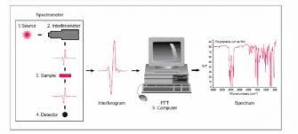

*Figure: How FTIR procedure is carried out*

1. **Scanning Electron Microscope (SEM) testing.**

Scanning electron microscopy, or SEM, produces detailed, magnified images of an object by scanning its surface to create a high resolution image. SEM does this using a focused beam of [electrons](https://www.universetoday.com/73207/what-are-electrons/). The electron source generates electrons at the top of the microscope’s column. The anode plate has a positive charge, which attracts the electrons to form a beam. The condenser lens controls the size of the beam, and determines the number of electrons in the beam. The size of the beam will define the resolution of the image. Apertures can also be used to control the size of the beam. The scanning coils deflect the beam along x and y axes, to ensure it scans in a raster fashion over the surface of the sample. The objective lens is the last lens in the sequence of lenses that create the electron beam. As the lens closest to the sample, it focuses the beam to a very small spot on the sample .Electrons cannot pass through glass, so SEM lenses are electromagnetic. They are made up of a coil of wires inside metal poles. When a current passes through these coils they generate a [magnetic field](https://www.khanacademy.org/science/physics/magnetic-forces-and-magnetic-fields/magnetic-field-current-carrying-wire/a/what-are-magnetic-fields).Electrons are highly sensitive to these magnetic fields, which therefore enables the lenses in the microscope to control them.

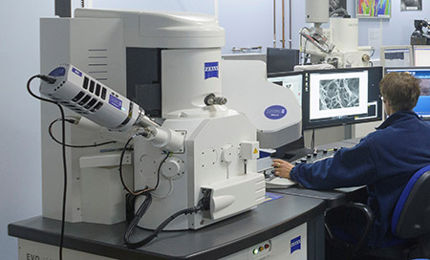

*Figure: a scientist using the Scanning Electron Microscope*

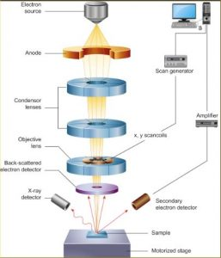

*Figure: Working of SEM*

WEEE DIRECTIVEES

WEEE stands for **W**aste from **E**lectrical and **E**lectronic **E**quipment. The first EU WEEE Directive, which took effect in February 2003, mandates the treatment, recovery and recycling of electric and electronic equipment. This Directive provided for the creation of collection methods where consumers return their WEEE free of charge. WEEE 2 Directive took effect on February 14, 2014.WEEE compliance aims to encourage the design of electronic products with environmentally-safe recycling and recovery in mind. RoHS compliance dovetails into WEEE by reducing the amount of hazardous chemicals used in electronics manufacture. RoHS regulates the hazardous substances used in the manufacture of electrical and electronic equipment (EEE), while WEEE regulates the disposal of this same equipment. All applicable products for the EU market must pass WEEE compliance and carry the "Wheelie Bin" mark. So manufacturers of EEE must not only follow RoHS compliance but also WEEE compliance for end-of-life. Previously, WEEE only covered specific equipment. Starting **August 15, 2018**, the scope of the WEEE widened to include all EEE, which is classified within 6 categories instead of the existing 11 RoHS product categories. Any batteries incorporated in WEEE are also collected per the WEEE Directive. As per WEEE Directive, after collection, batteries are to be removed (either manual, mechanical, chemical or metallurgic handling) from the product and counted towards the collection targets of the separate EU Batteries Directive. They are also subject to the recycling requirements of the Batteries Directive. The Directives in India and The European Union are very much alike.

**CONCLUSION**

The European Union is an organization where various countries in the European continent have come together. Hence the data is representative of all the countries collectively. The EU was the first one to initiate the directives and India took inspiration from the same and enacted its directives. Hence, the directives in India are very much inspired by that of the European Union. The EU hence has a large number of testing facilities and they have been working, improving and amending the directives as per the growing numbers in the E-waste generated. In the EU, especially in countries like Switzerland the data collection is taken very seriously and the data is very close to reality. Hence they are able to take the necessary steps in the right direction and actually able to create a difference in solving the issues. The permissible limit of various harmful substances are as follows:

|  |  |
| --- | --- |
| **EU’s Permissible limits** | **India’s Permissible limits** |
| Cadmium <100 PPM (0.01%) | Cadmium <100 ppm(0.01%) |
| Lead< 1000 PPM (0.1%) | Lead< 1000 PPM (0.1%) |
| Mercury< 1000 PPM(0.1%) | Mercury< 1000 PPM(0.1%) |
| Polybrominated Biphenyls < 1000 PPM (0.1%) | Polybrominated Biphenyls < 1000 PPM (0.1%) |
| PolyBrominated Diphenyles Ether <1000 PPM(0.1%) | PolyBrominated Diphenyles Ether <1000 PPM(0.1%) |
| Bis phthalate <1000 PPM(0.1%) |  |
| Benzyl butyl phthalate(BBP) <1000 PPM(0.1%) |  |
| Diisobutyl phthalate(DIBP) <1000 PPM(0.1%) |  |

This table just proves that how similar the permissible limits are and hence the how similar the directives are. As well as there are various other harmful substances defined in the Directives and there were included during the latest amendment in RoHS3. This shows there are continuous development in the resolution of the issue.

India is a growing consumer market. Though, India is not a manufacturing base; mostly products are imported from the countries like China, Taiwan, and Malaysia etc. India has very limited companies involved in manufacturing and core design. The basic needs of these sectors are the capabilities of leading edge technology and availability of local markets. The present situation is conducive in both ways for the growth of India's design and manufacturing sectors. The manufacturing units, however, procure components, semiconductor ICs etc. mostly from neighboring countries. The present RoHS rules in India will have a significant impact on the business of electronics products. Indian industry need now to procure the components, modules and other peripheral items, which do not contain restricted chemicals to obey the RoHS rules. The industry would be affected due to the rules, as they would be responsible for dumping of hazardous substances. Presently, India is a major market for the non-compliant products. The electronic and hardware sector in India are mainly assembling and trading units. Every electronics and electrical units now need to abide by the electronic waste rule in India and therefore would force to procure components, modules, products, which are strictly complied with the rule. It would be very difficult for the Indian industry to meet the criteria in the near future as the industry works with very competitive and thin profit margins.

The alternative components, modules and products will be expensive. Extensive research and development is needed to find suitable alternative substances, providing the same functionality and reliability as the banned substances. Elimination of specific substances requires a great deal of research and development of alternative substances, which needs investment of time and resources of electronics manufacturers throughout the supply chain. This effort is technically challenging and sometimes unfeasible due to the complexity of electronic products. The technological know-how on the green electronics of RoHS compliant substances is available with developed countries. The technology cost is substantially high due to the involvement of major fund requirement for research and development. In order to honor the rule, the manufacturers need to make products with RoHS compliant substance, which result in increased costs. The manufacturer will defiantly pass on additional cost to the consumer. These additional costs and technical challenges would make it very difficult for Indian manufacturers to compete globally. This change would not only affect the electronics industry, but also other industry like electrical, power, telecommunication, automotive etc. where electronic products are used.

The RoHS compliance cost for Indian electronic companies would also enhance between 1.9% to 5.2% of annual revenues or turnover, depending on the size of the industry. Procurement of alternative materials for the components would definitely be costlier. The import cost of the components and modules for most of the Indian companies would be high, being assembly unit. This higher import cost would further strain their operating profit. There will be a substantial rise in bills of materials for meeting the RoHS compliant products. The net profit margin of the local companies would further fall and in some cases would be difficult to sustain.

**THE IMPACT OF ROHS AND WEEE DIRECTIVES**

*Figure: Impact of RoHS directives in EU*

*Figure: Impact of RoHS directives on substances in Mobile and Television*

The testing facilities in the EU are also quite advanced as the machines and equipment used in the testing centers in our country are imported from various manufacturers in Europe.

The major learning from this comparison is that in our country the data collection reports have to be more transparent and should focus on accepting that we lack in the correct management on E-waste and then we need to be more pro-active rather than be reactive and make changes or implement steps only when other nations are doing it. We are one of the largest producers of E-waste and also the biggest smartphone market in the world and hundreds of these devices are disposed incorrectly and they end up in dumping grounds rather than in recycling centers. This in turn harms us by polluting are ground water resources as well end up harming the health of people working in these areas. Manufactures need to be stricter and should follow the given directives more effectively. This is seen in the EU and hence they are seeing results even though the complete issue is not resolved.

**BIBLIOGRAPHY**

References:

1. Start date:4/3/2022

wikipedia:-https://en.wikipedia.org/wiki/Restriction_of_Hazardous_Substances_Directive

1. Start date:11/03/2022

<https://moef.gov.in/en/project-approvals/hazardous-waste-import-and-export-clearances-1/importexport-of-hazardous-other-waste-archive/>

1. scimed.co.uk/education/sem-scanning-electron-microscopy/#:~:text=Scanning%20electron%20microscopy%20works%20by,which%20act%20to%20focus%20it.
2. <https://www.rohsguide.com/rohs-testing.htm> (5-03-2022)
3. <https://www.google.com/url?sa=i&url=https%3A%2F%2Fwww.winning-dwi-defenses.com%2Fbasics-of-gas-chromatography-mass-spectrometry%2F&psig=AOvVaw0IuuVZmqa4_kvAJl29Zx9l&ust=1650218473916000&source=images&cd=vfe&ved=2ahUKEwjbz-SAlZn3AhXMitgFHQiyCEQQr4kDegUIARDeAQ>(06-03-2022)
4. Study on RoHS and WEEE Directives Final report of European Commission DG Enterprise and industry 06/11925/AL by Arcadis Ecolas and RPA<<http://ec.europa.eu/environment/waste/weee/pdf/r> pa_study.pdf>
5. [www.itu.int](http://www.itu.int)
6. [www.claigan.com](http://www.claigan.com)
7. [www.electronicsweekly.com](http://www.electronicsweekly.com)
8. <https://www.researchgate.net/figure/Working-principle-of-Fourier-transform-infra-red-spectrometer-Infra-red-IR-spectra_fig2_319135784>
9. <https://www.twi-global.com/what-we-do/services-and-support/failure-analysis-and-repair/microscopy/scanning-electron-microscopy-sem-analysis-and-imaging>(
10. <https://link.springer.com/article/10.1007/s11356-021-13206-z>
11. <https://kemptechnologies.com/in/about-us/policies/weee/>
12. <https://www.tuv.com/switzerland/de/elektro-und-elektronikger%C3%A4te-stoff-verordnung-(elektrostoffv).html>
13. <https://moef.gov.in/wp-content/uploads/2017/08/Plastic-Waste-Management-Second-Amendment-Rules-2021.pdf>
14. <https://moef.gov.in/wp-content/uploads/2018/03/SO1002.pdf>(20-03-2022)
15. <https://moef.gov.in/wp-content/uploads/2018/03/HAZMAT_2265_eng.pdf>(18-03-2022)
16. <https://moef.gov.in/wp-content/uploads/2017/08/OM-Dated-14062021-on-exemption.pdf>(1-04-2022)
17. <https://moef.gov.in/wp-content/uploads/2017/08/OMPlasticImport.pdf>
18. <https://moef.gov.in/wp-content/uploads/2019/05/Gazette-notification-of-PCB_0.pdf>(11-03-2022)
19. <https://moef.gov.in/wp-content/uploads/2019/05/Stockholm-convention.pdf>
20. <https://moef.gov.in/wp-content/uploads/2022/04/Rules-to-Contain-Environmental.pdfa>(15-03-2022)
21. <https://www.europarl.europa.eu/news/en/headlines/society/20201208STO93325/e-waste-in-the-eu-facts-and-figures-infographic>(2-04-2022)
22. <https://ec.europa.eu/environment/topics/waste-and-recycling/rohs-directive_en>(1-04-2022)
23. <https://eur-lex.europa.eu/legal-content/EN/TXT/?uri=CELEX:32011L0065(1-04-2022)>
24. <https://eur-lex.europa.eu/legal-content/EN/TXT/?uri=CELEX%3A02011L0065-20200501>(08-04-2022)